PROJECT TITLE: EXPLORATORY DATA ANLYSIS WITH SALES DATA

(NOTEBOOK CREATED BY: SANCHAITA CHAKRABORTY)

STUDENT NAME: ANJALI SRIVASTAVA,
BSC(HONS) MATHS ,BHU

Period of Internship: 18th May 2026 – 14th June 2026

Report submitted to: IDEAS – Institute of Data Engineering, Analytics and Science Foundation, ISI Kolkata

- Abstract
This project focuses on performing exploratory data analysis on sale dataset to identify important trends in store and department level performance. The project analyzes revenue distribution, department consistency, holiday effects, seasonal trends, and revenue contribution. Python-based data analysis techniques were used to clean, process, and visualize the data. Statistical measures such as mean, standard deviation, and coefficient of variation were used to understand sales behavior. Additionally, a machine learning application was implemented using K-Means clustering on the MNIST dataset. The clustering results were evaluated using the macro F1 score after mapping cluster labels to actual digit classes. The project demonstrates the application of data analytics and unsupervised machine learning techniques for extracting meaningful insights from data.

- Introduction
Data analysis plays an important role in understanding business performance and making informed decisions. With increasing availability of sales data, organizations can analyze customer behavior, identify high-performing areas, and improve operational strategies.
This project, "Exploratory Data Analysis with Sales Data", focuses on analyzing weekly sales records from different stores and departments. The project uses Python programming and data science libraries to perform data manipulation, statistical analysis, and machine learning tasks.
The sales dataset contains information about store IDs, departments, dates, weekly sales, and holiday indicators. The analysis helps identify top-performing stores, stable and volatile departments, seasonal sales patterns, and the effect of holidays on revenue.
The project also introduces unsupervised machine learning through K-Means clustering using the MNIST handwritten digit dataset. The clustering algorithm groups similar digit images and its performance is evaluated using the F1 score.

Technologies Used:
- Python
- Google Colab
- Pandas
- NumPy
- Matplotlib
- Scikit-learn
Topics Covered During First Two Weeks of Internship Training:
- Introduction to Python programming
- Data types and data structures
- Python libraries for data analysis
- NumPy fundamentals
- Exploratory Data Analysis
- Basics of Machine Learning
- Single Layer Perception (SLP)
- Multi-Layer Perception (MLP)
- Introduction to Clustering Practice
- Large Language Model Fundamentals

- Project Objective
The objectives of this project are:
- To analyze sales data and identify patterns in store and department performance.
- To determine the highest and lowest revenue-generating stores.
- To study department-wise sales stability using statistical measures.
- To analyze the effect of holidays and seasonal changes on sales.
- To identify store-department combinations contributing significantly to revenue.

- Methodology
The project followed a structured data analysis workflow.

Step 1: Data Collection
The sales dataset was obtained from the provided internship resource folder. The dataset was downloaded as a CSV file and imported into Google Colab.

Step 2: Data Loading
The dataset was loaded into a Pandas DataFrame using Python.
Libraries used:
- Pandas for data handling
- NumPy for numerical operations

Step 3: Data Preprocessing
The following preprocessing steps were performed:
- Loaded CSV data into DataFrame.
- Checked column names and dataset structure.
- Converted date values into datetime format.
- Extracted month information from dates.
- Grouped data based on required attributes.

Step 4: Exploratory Data Analysis
The following analyses were performed:

Store Revenue Analysis
- Sales were grouped by store ID.
- Total revenue was calculated.
- Stores were ranked based on sales.
- Top and bottom performing stores were identified.

Department Consistency Analysis
Department sales were analyzed using:
- Mean weekly sales
- Standard deviation
- Coefficient of Variation
Lower CV indicated stable sales, while higher CV indicated volatile sales.

Holiday Analysis
Holiday and non-holiday sales were compared.
Percentage change in sales was calculated to identify whether holidays increased revenue.

Seasonal Analysis
The month was extracted from the date column.
Average monthly sales were calculated to identify:
- Highest sales month
- Lowest sales month

Store-Department Contribution Analysis
Store and department combinations were grouped to find their contribution toward total revenue.

Step 5: Machine Learning Model
The MNIST digit dataset was loaded using Scikit-learn.
Features and labels were separated:
- X → image features
- y → digit labels
K-Means clustering was applied with 10 clusters.
The cluster labels were mapped to actual digit labels and evaluated using macro F1 score.

Workflow
Data Collection
↓
Data Loading
↓
Data Cleaning
↓
Exploratory Analysis
↓
Statistical Evaluation
↓
Visualization
↓
Machine Learning Model
↓
Performance Evaluation

- Data Analysis and Results

5.1 Descriptive Analysis
The sales dataset was analyzed using descriptive statistics to understand store performance, department behavior, seasonal patterns, and holiday effects.

5.1.1 Store-wise Revenue Analysis
Sales were aggregated based on store_id to calculate total revenue generated by each store.
Analysis | Result
Highest Revenue Stores | 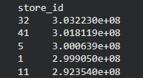
Lowest Revenue Stores | 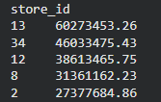
Comparison | High-performing stores generated significantly higher revenue compared to low-performing stores
Observation:
The ranking of stores based on total revenue helped identify the strongest and weakest performing stores. Department-wise comparison showed that some departments contributed more consistently to store revenue.
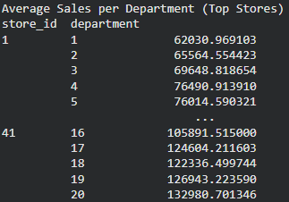
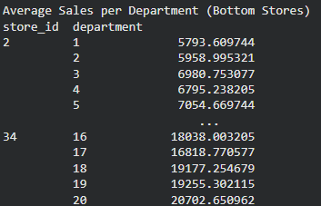

5.1.2 Department Performance Consistency
Department performance was evaluated using:
- Standard deviation
- Coefficient of Variation (CV)
Coefficient of Variation was calculated as:
CV = Standard Deviation / Mean
Category | Interpretation
Low CV | Stable department sales
High CV | Volatile department sales
Results:
- Departments with lowest CV values were identified as the most stable.
- Departments with highest CV values showed large fluctuations in weekly sales.
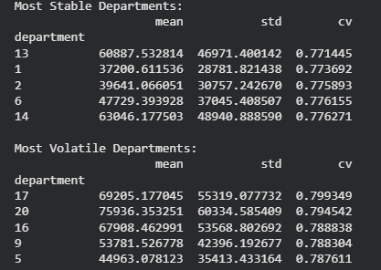

5.1.3 Holiday vs Non-Holiday Sales Analysis
Weekly sales during holiday and non-holiday periods were compared.
Category | Average Weekly Sales
Holiday Weeks | 84493.825439
Non-Holiday Weeks | 52852.575328
Percentage change: 59.87%
Observation:
The analysis determined whether holidays increased customer spending. Departments with the highest positive percentage change were considered the main beneficiaries of holiday periods.
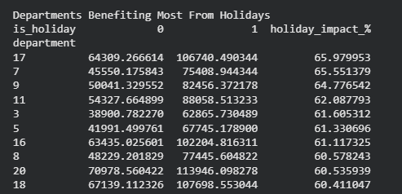

5.1.4 Seasonal Trend Analysis
The date column was converted into date-time format and monthly sales trends were analyzed.
Finding | Result
Highest Sales Month | 11
Lowest Sales Month | 5
Observation:
Sales variation across months indicates seasonal purchasing patterns.
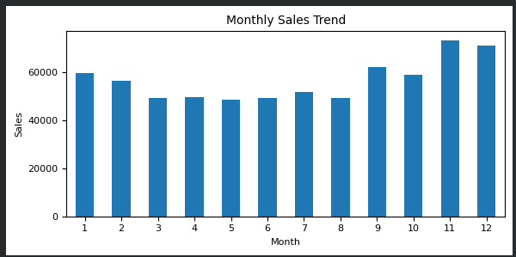

5.1.5 Store and Department Contribution Analysis
Revenue contribution was calculated by grouping data using:
- Store ID
- Department
Observation:
A few store-department combinations contributed a major share of total revenue, while others contributed less.
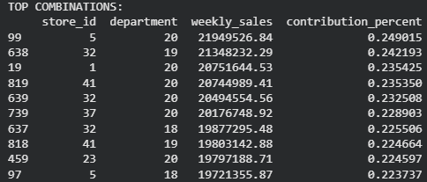
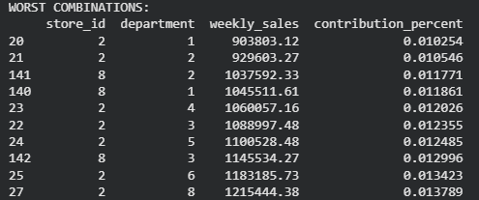

5.2 Machine Learning Analysis

5.2.1 MNIST Dataset Loading
The MNIST handwritten digit dataset was loaded using:
sklearn.datasets.load_digits
Dataset dimensions:
Variable | Shape
X (Features) | 1797 × 64
y (Target Labels) | 1797

5.2.2 K-Means Clustering
K-Means clustering was applied with:
Number of clusters = 10
The model grouped similar digit images into clusters.
The generated cluster labels were stored in:
kmeans_labels

5.2.3 Model Evaluation
The clustering performance was evaluated using Macro F1 Score.
Model | Evaluation Metric | Score
K-Means Clustering | Macro F1 Score | 0.7894620863890832
Observation:
The F1 score indicates how accurately the generated clusters corresponded to actual digit classes after label mapping.

5.4 Inferential Analysis
No hypothesis testing was performed in this project. The analysis was based on descriptive statistics and machine learning evaluation metrics.

6. Conclusion
The project successfully demonstrated the application of exploratory data analysis and machine learning techniques on real-world datasets.
The analysis identified differences in store performance, department stability, seasonal variations, and holiday effects. Statistical methods helped understand sales fluctuations and revenue contribution.
The K-Means clustering model demonstrated how unsupervised learning can be applied to classify similar data points. The evaluation using F1 score provided a measure of clustering effectiveness.

- APPENDICES
1. Project Notebook link:
https://colab.research.google.com/drive/18FpWiol3b7-oLNIuhHnjcwQj--LSUAi2?usp=sharing
2. Dataset : sales.csv

